## Modulette_groups table

## Fields

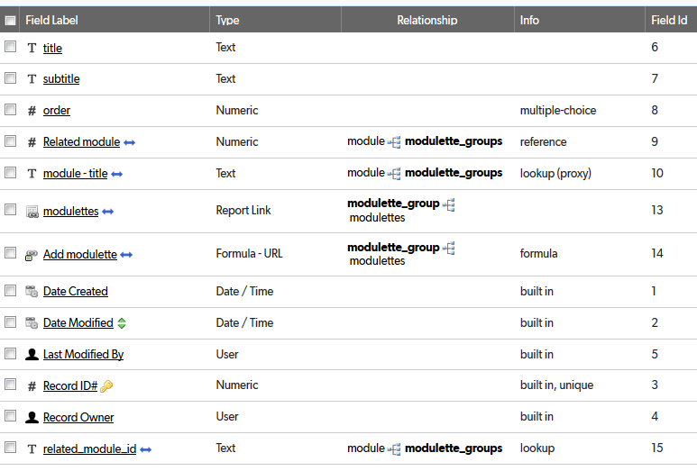

## Relationships

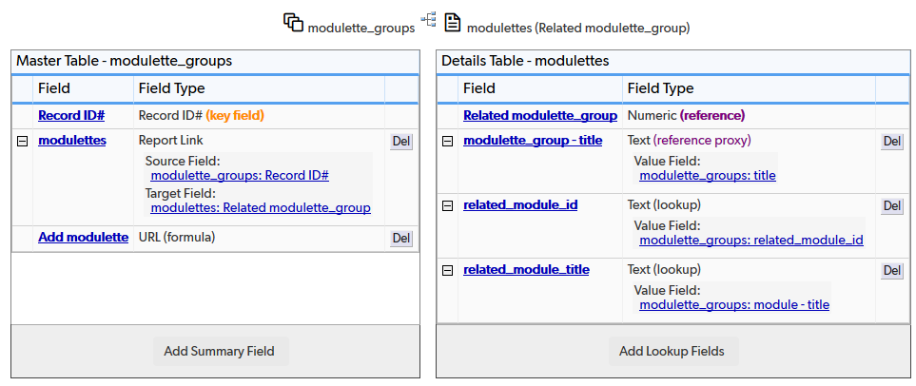

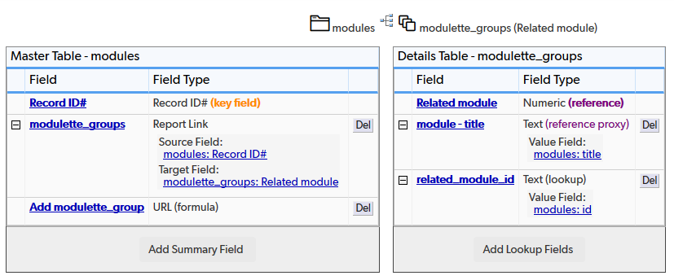

## Field settings

Note: Built-in fields use the default settings

title 3

subtitle 5

order 6

Related module 8

module – title 10

modulettes 11

Add modulette 12

related_module_id 14

# title

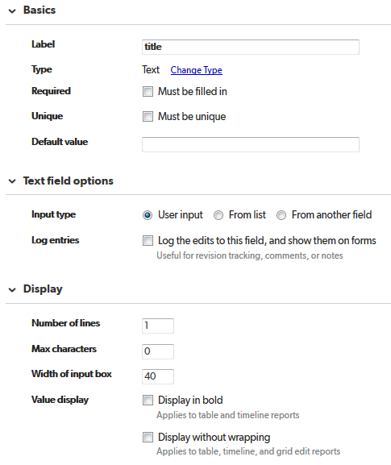

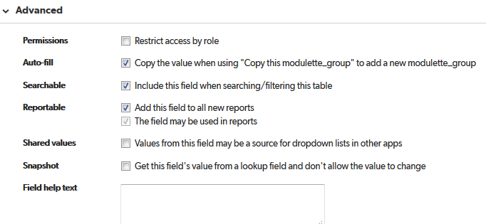

# subtitle

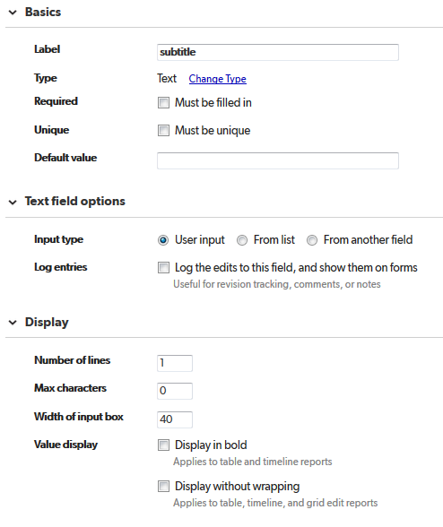

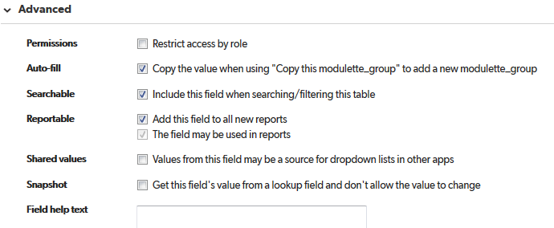

# order

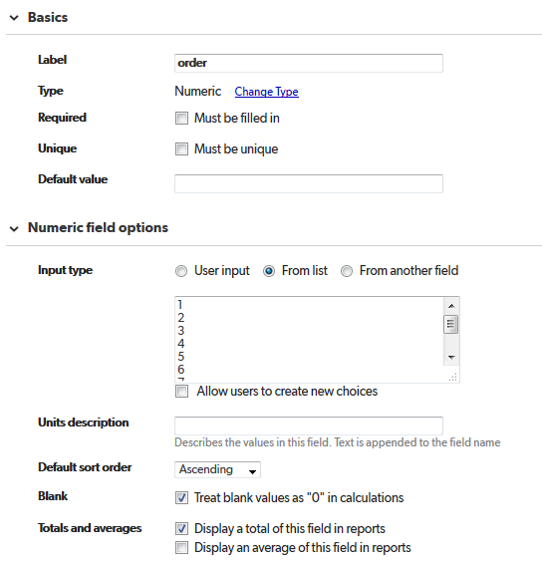

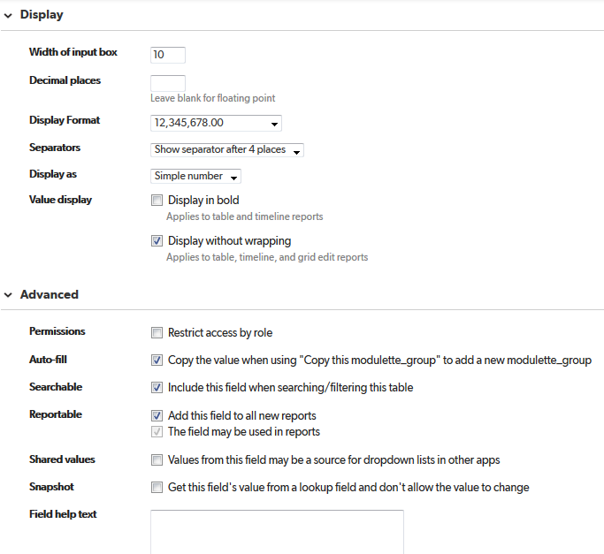

Related module  
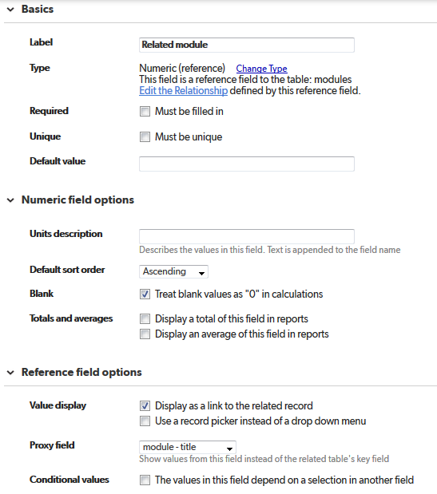 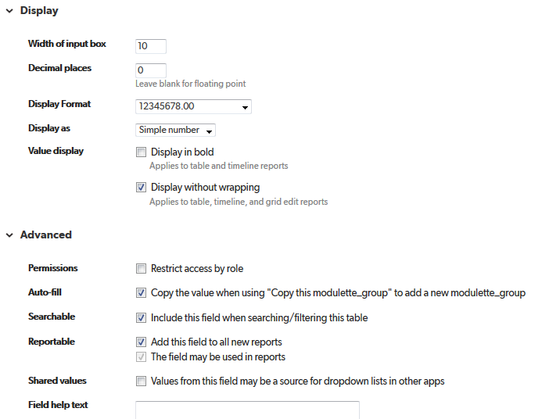

module – title  
  
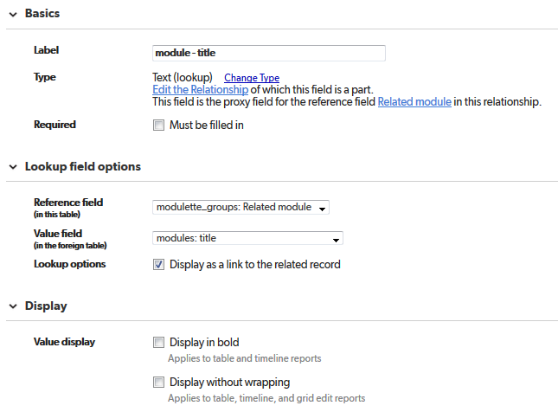

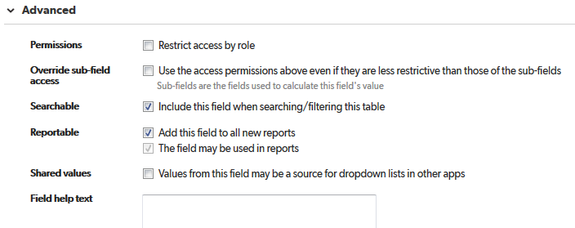

# modulettes

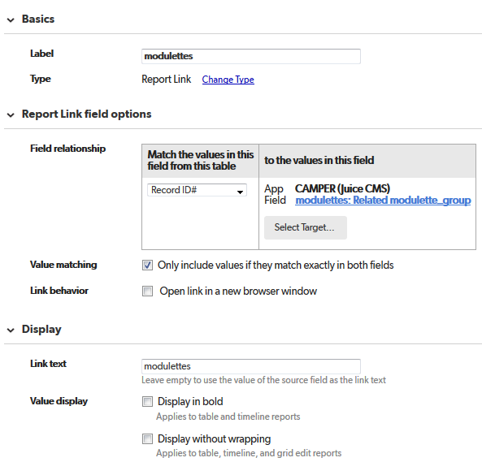

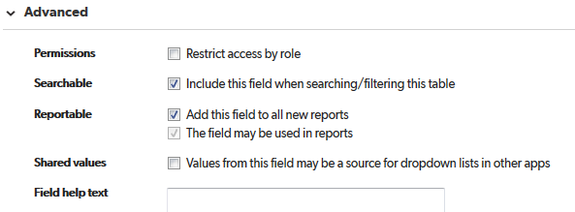

# Add modulette

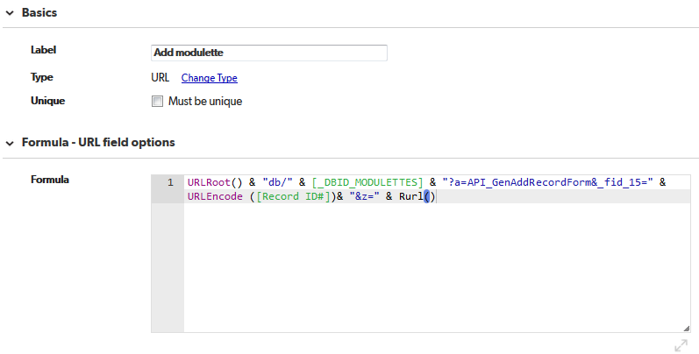

URLRoot() & "db/" & [_DBID_MODULETTES] & "?a=API_GenAddRecordForm&_fid_15=" & URLEncode ([Record ID#])& "&z=" & Rurl()

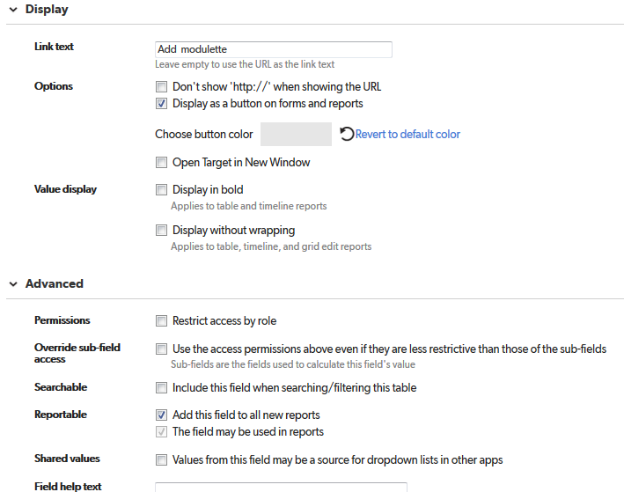

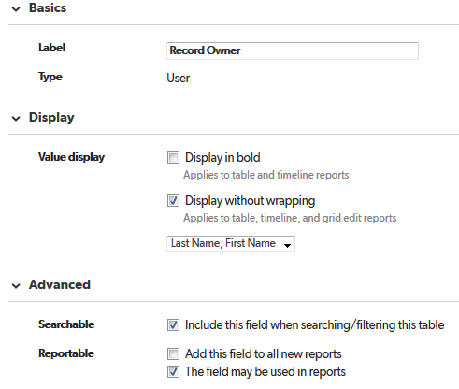

# related_module_id



  
  
  